Requirement Analysis — Technology Stack
Implement Client Script & UI Policy (Incident)
01 October 2026 | Requirement Analysis | SWTID-2026-4755
Field | Project value
Date | 01 October 2026
Team ID | SWTID-2026-4755
Project Name | Implement Client Script & UI Policy (Incident)
Analysis focus | Native ServiceNow platform, UI Policy, Client Scripts, and Incident data model
1. Technical architecture summary
The project is a native ServiceNow configuration solution. It does not require a separate React frontend, Node.js backend, MongoDB database, external API, Tableau/Power BI layer, or AI model. The standard ServiceNow Incident form and list are the user interface; UI Policies and Client Scripts provide conditional behavior; the Incident table and native history/reporting provide persistence and auditability.
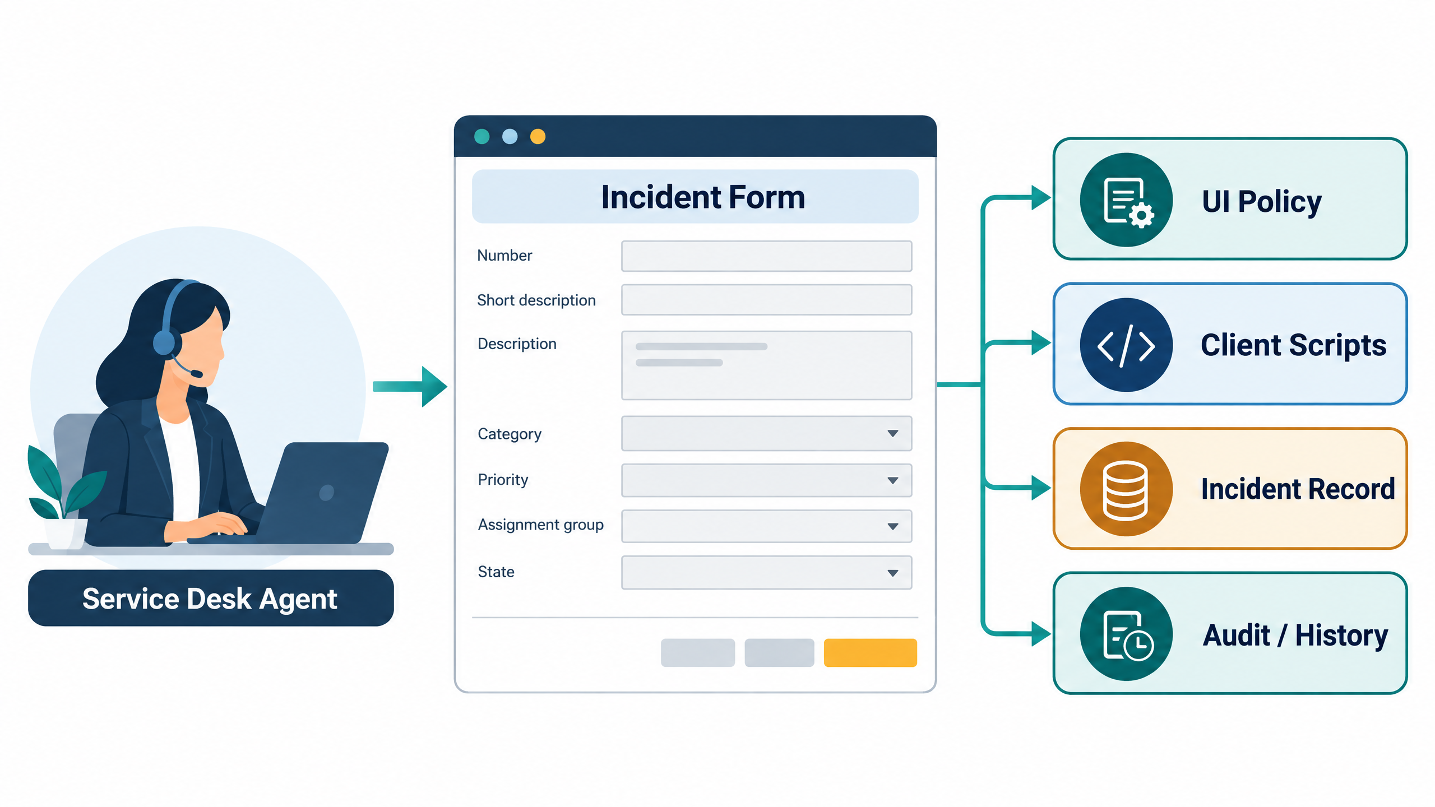
Generated project architecture visual: ServiceNow Incident experience and control layers.
2. Components and technologies
Component | Technology / object | Role in this project
User interface | ServiceNow Incident form and Incident list | Capture Impact, Urgency, Assignment group, Assigned To, State, and description; present messages and field states.
Conditional policy | UI Policy: High Impact Control | Condition Impact is 1 – High; applies mandatory/read-only actions and reverses when false.
Policy actions | UI Policy Actions | Assignment group mandatory; Urgency read-only while the policy is active.
Event logic | Client Scripts | onChange on Impact, onSubmit on Incident form, and onCellEdit on State.
Data storage | Incident table | Persist Incident fields and the resulting valid record.
Audit / reporting | ServiceNow history and native reporting | Retain changes and support triage, SLA review, and operational reporting.
Authorization boundary | ServiceNow roles, ACLs, and server-side policies | Remain authoritative; client controls improve data quality and usability.
3. Field and event contract
Field / event | Type | Contract
Impact | Incident field | Value 1 represents High and activates the UI Policy/onChange behavior.
Urgency | Incident field | Set to 1 / High when Impact becomes High; read-only under the UI Policy.
Assignment group | Incident field | Mandatory when Impact is High.
Assigned To | Incident field | Required before submit when Impact is High.
State | Incident field | Direct list edit is rejected; form update remains allowed.
onChange | Client Script type | Runs when Impact changes; skips loading/blank values.
onSubmit | Client Script type | Returns false for invalid high-impact ownership; otherwise true.
onCellEdit | Client Script type | Calls callback(false) for State list editing.
4. Why this stack fits
• Uses the platform’s standard Incident experience, reducing adoption friction.
• Keeps high-impact rules close to the field and event where the risk appears.
• Provides clear, deterministic behavior that is simple to test and explain.
• Avoids unnecessary external infrastructure for a small workflow-governance problem.
• Leaves room for future server-side enforcement if integrations must follow the same rules.

